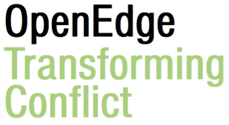

OpenEdge and New Paradigm Prototyping
“...a reunification, a restoring, where we can experience ourselves as essential in an interconnected life system.”

At OpenEdge we are working from the premise that a new way of being, organising and experiencing our existence has been emerging into the main stream* (*of the dominant paradigm of the global north) within our lifetimes. We experience this in many different ways, in scholarship of many disciplines, in spirituality, in activism and in communities. Like others, in OpenEdge, we sense that we are witnessing a growth of (*re)awakening to the interconnectedness of our whole system.

As this new spectrum of complexity emerges, we are still frustratingly bound by habitual black and white thinking and divisions. We fall into competing for rightness and resources in the context we are within – one of scarcity and separation, with patterns of domination of one person over another, uneven power distribution and systemic privilege implicit.

In OpenEdge we engage with this through the entry points of identity, conflict and transition - making the implicit explicit and developing tools, systems and a consciousness to support inclusive processes which take us together into a future where we can meet more of our needs more of the time.

We support the experimentation and development of alternatives to the old story and seek to nurture multiple, ongoing deconstructions and reconstructions of ‘how we can be instead’. Understanding identity differently, and transforming how we relate to conflict are essential if we are working in new economics, with children, international development, prison reform, ecology, social justice, or anything in between.

At OpenEdge we offer inputs to learn, explore, experience, research, practice, design, embody, and compassionately critically reflect, new ways of being personally and systemically with:

The Otherness Lab
OpenEdge Festival of Conflict
OpenEdge Transition Lounge

We begin in the knowledge we are essential and how we are impacted matters, with the simple act of reaching out in curiosity - connecting to the experience of each other - to begin restoring connectivity and flow back into more alive systems of human encounter.

